WINDOWS SERVER BASICS & INSTALLATION

Question 1: Install Windows Server on a virtual machine using VirtualBox or VMware and take a screenshot of the desktop after the installation is complete.

Answer / Steps
- First, I would install VirtualBox or VMware on my computer.
- Next, I would download a Windows Server ISO file from Microsoft's official website.
- I would create a new virtual machine and select the Windows Server ISO file.
- Then, I would allocate suitable RAM, processor cores, and virtual hard-disk space.
- I would start the virtual machine and follow the Windows Setup instructions to install the server.
- After the installation, I would set the Administrator password and sign in to the server.
- Finally, I would take a screenshot of the Windows Server desktop.
Figure 1: Example of the Windows Server installation screen (AI-generated illustration).
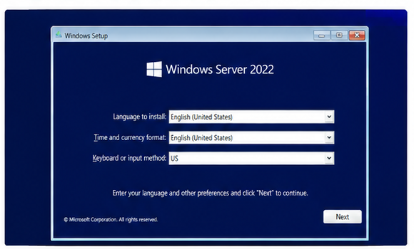

Question 2: Open Server Manager and use the Add Roles and Features wizard to install the Active Directory Domain Services (AD DS) role. Document each step with a short description and screenshot.

Answer / Steps
- I would sign in to Windows Server and open Server Manager.
- From the top menu, I would click Manage and select Add Roles and Features.
- I would select Role-based or feature-based installation and choose the local server.
- On the Server Roles page, I would tick Active Directory Domain Services (AD DS).
- If a window asks to add required features, I would click Add Features.
- I would click Next through the remaining pages and then click Install.
- After the installation finishes, I would take a screenshot showing that AD DS has been installed.
Figure 2: Example of Server Manager and AD DS role selection (AI-generated illustration).
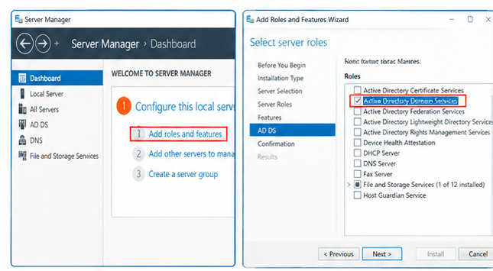

Question 3: Promote your Windows Server to a Domain Controller by creating a new forest with a root domain name of your choice (for example, mycollege.local). List the options selected during the configuration.

Answer / Steps
For this example, I have selected the domain name mycollege.local.
- After installing AD DS, I would open Server Manager and click the notification flag.
- I would select Promote this server to a domain controller.
- In the Deployment Configuration window, I would select Add a new forest and enter mycollege.local as the root domain name.
- I would select the required domain controller options. DNS Server and Global Catalog would normally remain selected for this setup.
- I would create a Directory Services Restore Mode (DSRM) password and keep it safe.
- I would review the settings and prerequisite checks, then click Install when the option becomes available.
- The server would restart after the configuration. I would sign in again using the domain Administrator account.
- I would take a screenshot showing the domain controller configuration.
Figure 3: Example of creating a new forest and promoting the server (AI-generated illustration).
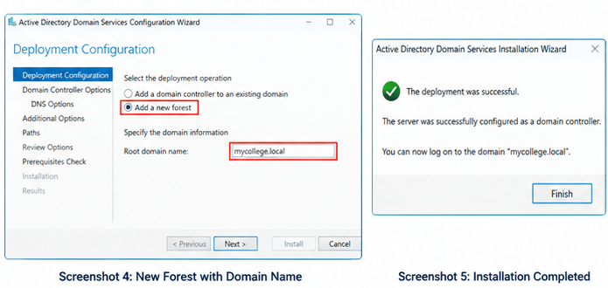

Question 4: Create two new user accounts and one group in Active Directory Users and Computers. Add both users to the group and describe the steps you followed.

Answer / Steps
For this example, I have used user1 and user2 as the usernames and IT-Group as the group name.
- I would open Server Manager, click Tools, and select Active Directory Users and Computers (ADUC).
- I would expand the mycollege.local domain and select the Users container.
- I would right-click Users, choose New, and then select User.
- I would create the first account with the username user1 and repeat the same steps to create user2.
- Next, I would right-click the Users container, select New, and choose Group.
- I would name the group IT-Group and select Global and Security group settings.
- I would open IT-Group Properties and select the Members tab.
- I would click Add, enter user1 and user2, click Check Names, and then click OK.
- Finally, I would check that both users are listed in the Members tab and take a screenshot.
Figure 4: Example of user accounts and group membership (AI-generated illustration).
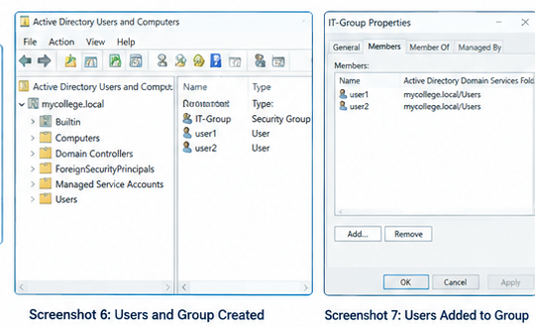

Conclusion
In this assignment, I learned the main steps used to install Windows Server in a virtual machine and add Active Directory Domain Services. I also learned how a server can be promoted to a Domain Controller by creating a new forest, and how to create user accounts and add them to a group in Active Directory.

